**Task Description:**

Create a simple script file and push it to repo. Create a project in Jenkins connected to your GitHub repository. When a commit is made to your repo, automatically build must get triggered from Jenkins and the output must be shared to me via email.

**Step 1: Launch an instance in EC2 (Amazon linux 2023)**

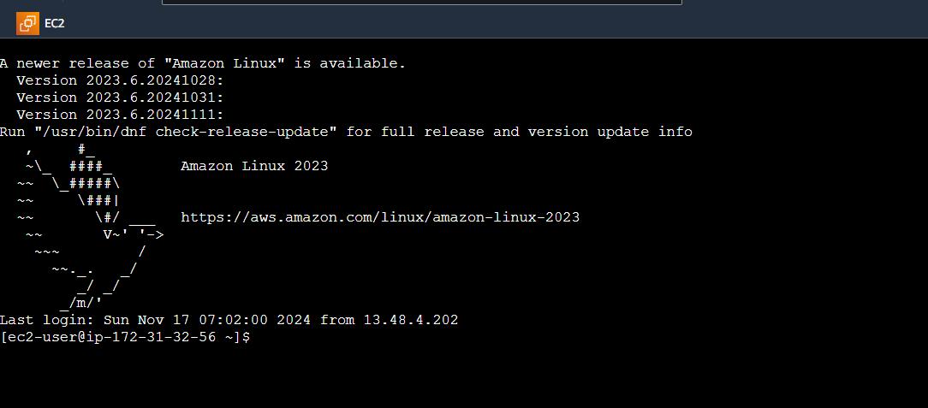

**Step 2: Downloading Jenkins**

*~ sudo yum update –y*

*~ sudo wget -O /etc/yum.repos.d/jenkins.repo \ https://pkg.jenkins.io/redhat-stable/jenkins.repo*

*~ sudo rpm --import https://pkg.jenkins.io/redhat-stable/jenkins.io-2023.key*

*~ sudo yum upgrade*

**Step 3: Install Java and Jenkins**

*~ sudo dnf install java-17-amazon-corretto -y*

*~ sudo yum install jenkins -y*

**Step 4: Enable and Start Jenkins as a Service**

~ sudo systemctl enable Jenkins

~ sudo systemctl start jenkins

~ sudo systemctl status jenkins

**Step 5: Configuring Jenkins**

Connect to **http://13.59.154.163:8080** in our browser

~sudo cat /var/lib/jenkins/secrets/initialAdminPassword

**Step 6: Create admin Users in Jenkins**

**Instance Configuration**

**Jenkins is ready to use now**

**Step 7: Create GitHub Repository**

**Step 8: Clone git**

**~** git clone <repo_name>

**Step 9: Configure Jenkins to Integrate with Github**

**Install Plugins:**

* Go to Manage Jenkins → Manage Plugins and install:
  + Git plugin
  + GitHub Integration plugin
  + Email Extension plugin

**Step 10: Create Project in Jenkins**

**~** new project “Guvi_task_nov_23” with freestyle project

**Step 11: Connect to github**

*~ Under Source Code Management, choose Git and provide repository URL.*

*~ Add credentials for your GitHub account if needed.*

Under **Build Triggers**, check **GitHub hook trigger for GITScm polling**.

**Step 12: Create Webhook in GitHub Repository**

Go to GitHub repository → **Settings** → **Webhooks**.

Click **Add webhook**:

* **Payload URL**: http://<Jenkins-URL>/github-webhook/
* **Content type**: application/json.
* **Event trigger**: Choose Just the push event**.**

**Step 13: Configure Email Notifications in Jenkins**

**Step 14: Test the Setup**

Modify the script or add a new file to your repository and commit the changes.

Jenkinsshould automatically trigger a build. The output will be emailed to the configured address.

